Beginning
Capital Poster Project Rubric Name__________________________
For this project you will be working with an assigned partner to prepare a travel poster for the capital of a Spanish-speaking country. Your goal is to highlight the fun and exciting places and things that can be found in your capital city. You will be writing this poster in English. You will be presenting your poster to the class. You need to include the following items:

__1. The name of your capital and the country.
__2. A map showing where the capital is located in the country.
__3. A slogan for your capital. Your capital may already have a slogan (for example New York City is called the Big Apple) or you may create one that is appropriate.
__4. At least four pictures of places that would be great to visit in the capital AND captions with what activities a visitor would do there.
__5. One three dimensional object (please no food items unless you have approval from your teacher) with a caption as to why it represents the capital.

Remember your poster should be culturally appropriate, positive, interesting and attract people’s attention. The following would be examples of BAD SENTENCES!
- The population of Madrid is 3.3 million.
- San José is 17.23 square miles.
- México City is very contaminated.
- This is a picture of a museum.
- Come visit Lima, the capital of Argentina!
This project will be assess on the culture standard according to the following descriptions.
3 (4)- The assignment is culturally appropriate and on task (shows positive image of capital). Student demonstrates knowledge of practices and products of the culture.
2- Assignment is somewhat culturally appropriate and on task but fails in one area or more. For example, it may identify a certain building as being located in a certain capital that actually is in another capital.
1-. Assignment demonstrates some or little cultural information about the capital but is missing information and is failing in many areas.

Intermediate
Proyecto de un país hispano con el pretérito y el imperfecto Nombre_____________________
By yourself or with a partner you will be creating a powerpoint about a Spanish-speaking country. You are to imagine that you have visited this country on vacation and you are writing a travel diary about your activities there. You must include at least ten pictures on ten different slides about the places you visited there and the activities that you did. You will be presenting this presentation to the class next week (most likely Thursday or Friday).
On each slide you must include:
- An appropriate picture-make sure this is of a place that is in YOUR COUNTRY!
- Two sentences-one sentence in the preterit and one sentence in the imperfect.
For example: Fuimos a ver una corrida de toros en Madrid.
Era muy emociante!
You may not repeat any verb more than three times.

You will receive three grades for this assignment for each of the three standards of culture, speaking, and writing.
(10 points)For speaking you must have good pronunciation, appropriate pauses, and rate of speech. Would a native speaker understand you? If you work with a partner you must both speak.
(20)For writing you must use the preterit and the imperfect correctly. You must use a variety of vocabulary and verbs that would be appropriate for a Spanish 3 student.
(10) For culture you must include places and activities that can be seen/done in your country. For example, Bolivia is landlocked so it would be inappropriate to include a picture of the ocean in a presentation about Bolivia.

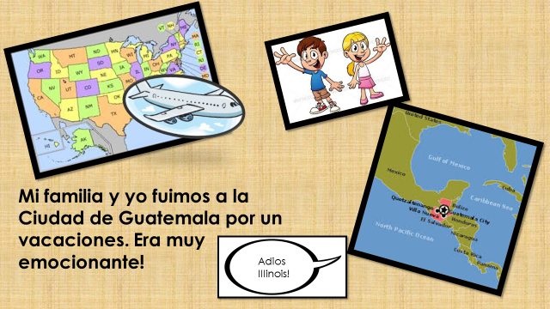
Slide example
Intermediate/Advanced
Presentación de la República Dominicana
In groups of three or four you are going to create a presentation about the Dominican Republic. You may create a Powerpoint or a prezi. You need to write in complete sentences in Spanish.
Your group will be randomly assigned either a resort or a community service project as the topic for your presentation. After you have received your topic follow the instructions for the corresponding topic below. You will be presenting your project to the class.

Resort- 4 slides/ 4 photos
- A map of where the resort is located
- What luxuries does the hotel have
- How much does it cost to stay a week
- What activities does the resort offer

Community service project- 4 slides/4 photos

- A map of where the project is located
- What problems does the location have
- How do the volunteers help
- How much does it cost to be a volunteer

Follow up questions: Is it okay for the Dominican Republic to have these extremely expensive resorts while there are people on the same island who are in severe financial need? What are the benefits and negatives to these resorts? Some of the community service project volunteers pay thousands of dollars to be a volunteer. Would it be better for them to just donate the money?
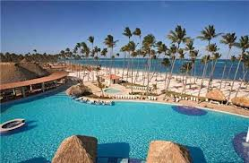 Resort in the Dominican Republic

